**TriggerAid**

High Speed Camera/Flash Trigger & Timelapse Controller

**The Board**

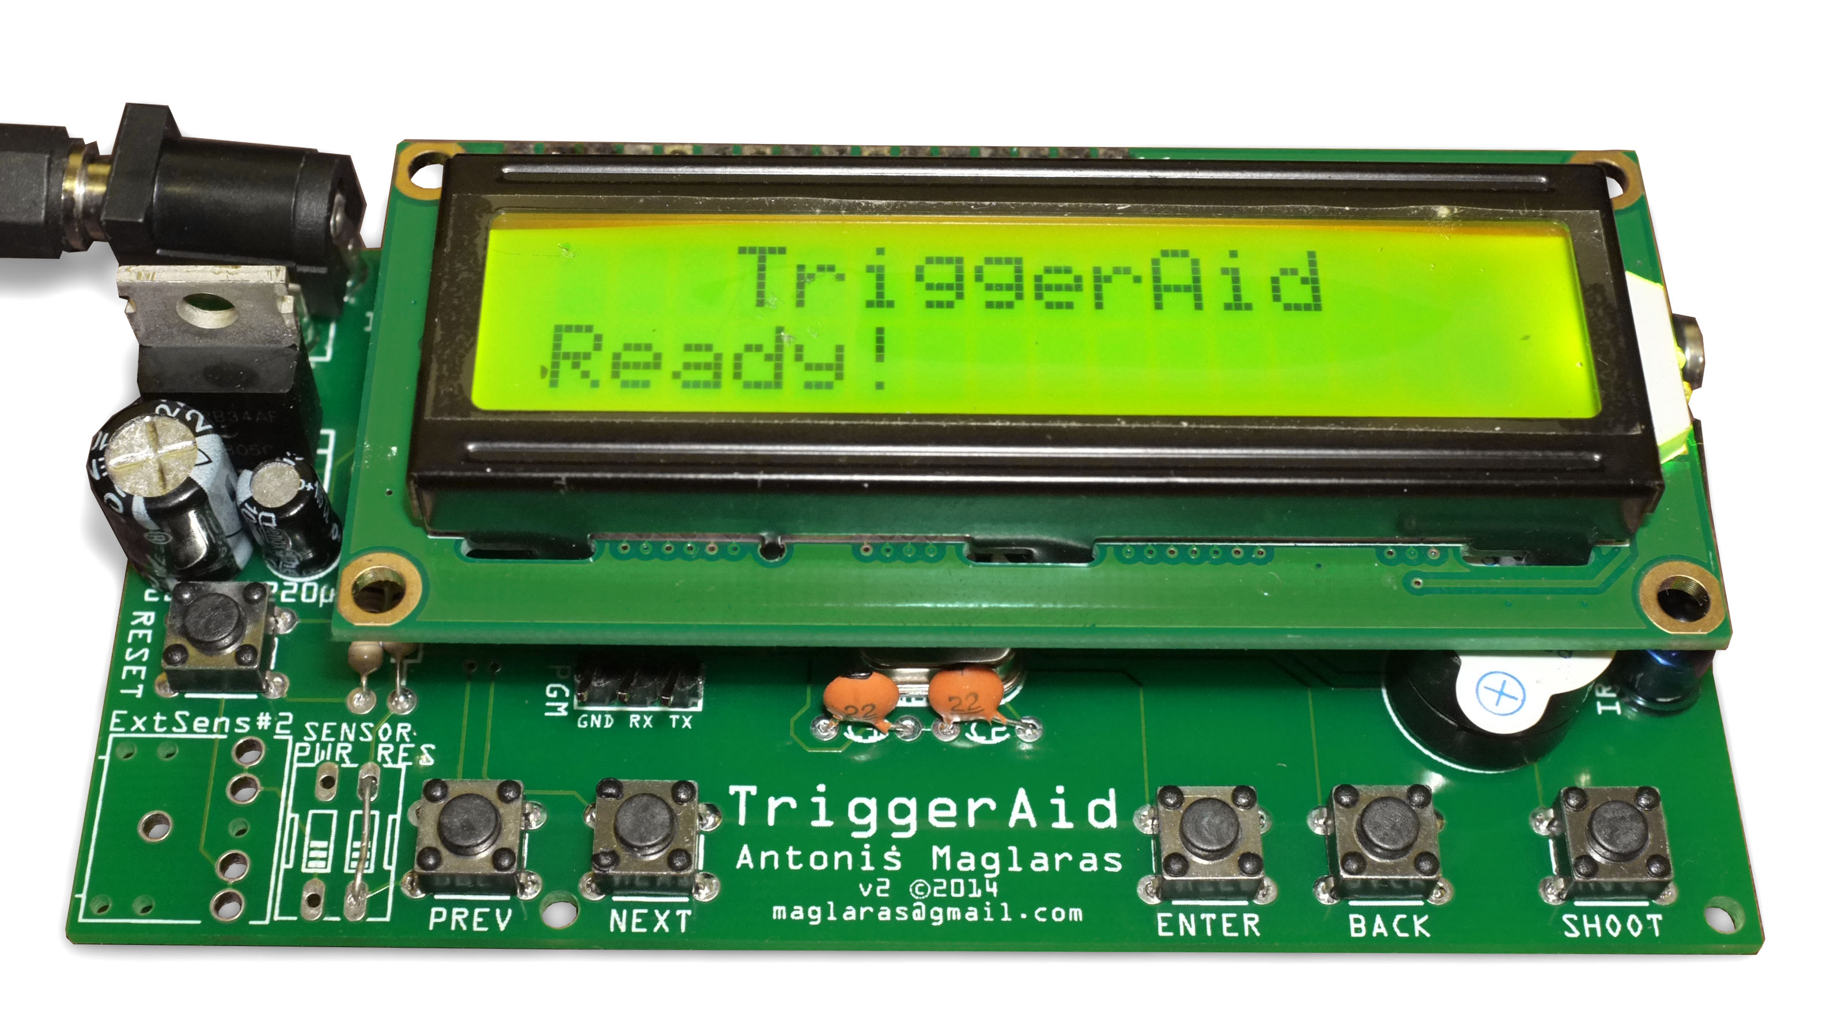

**Input/Outputs**

* TRS Jack (Stereo, 3.5mm, headphones-style) for connecting Camera or Flash (or whatever you want to trigger)
* Digital Sensor Input (+5V, Data, GND)
* DC Input (Center Positive, 7-18V)
* 6 Buttons (Reset, Previous/Next/Enter/Back/Shoot).

**Main Menu:**

The menu structure is the following:

* **Light Trigger**
  + On the first line, you can see the realtime reading from the light sensor from 0 to 100. In the last right character, an empty circle indicates that the trigger is not enabled, and when it’s filled black, indicates enabled triggering.
  + On the second line, you define the threshold (0..100) and the last character indicates if it will be triggered when the reading is more that the threshold (H / High) or lower (L / Low).

You can change the threshold from 0 to 100 and vise-versa using PREV/NEXT buttons. You can start the trigger with ENTER. Exit with BACK.

* **External Trigger**
  + On the first line you can see the selected trigger and if it is active or not.
  + On the second line you can see when it triggers, if it is responding HIGH or LOW (normally, a sound trigger for example will trigger HIGH when the sound is louder than the setting/threshold).

You can change from LOW to HIGH using PREV/NEXT buttons and you can start the trigger with ENTER. Exit with BACK.

* **Time Lapse**
  + On the first line you can see the remaining time for the shoot and if it’s active or not.
  + On the second line you can set the shooting interval (time between shoots) from 0 to 300 (time is in seconds).

You can change the values using PREV/NEXT buttons and you can start the trigger with ENTER. Exit with BACK.

* **Bulb Mode**
  + On the first line you can see the remaining time of the shoot and if it’s active or not.
  + On the second line you can set the exposure (bulb time) from 0 to 300 seconds.

You can change the exposure/bulb time using PREV/NEXT buttons and you can start the trigger with ENTER. Exit with BACK.

* **High Speed Burst**
  + On the first line you can see if it’s enabled or not.
  + On the second line you can set the interval (in ms / Milli Seconds).

You can change the interval using PREV/NEXT buttons and you can start the trigger with ENTER. Exit with BACK.

* **Setup Parameters**
  + Pre Focus. You can enable or disable the pre-focus delay. If it’s enabled, when you start a trigger mode, the TriggerAid will trigger the focus on your camera. It works only with wired camera connection.
  + Wired Triggers. You can select which trigger outputs are enabled or not. First only (usually Focus), Second only (usually Shoot), Both or None. None is used when you are using the IR connection to your camera.
  + Infrared Trigger. You can select the brand of your camera. Olympus, Pentax, Canon, Nikon, Sony, or Disable.
  + Light Trigger on HIGH/LOW. You can select the default value from HIGH to LOW.
  + External Trigger on HIGH/LOW. You can select the default value from HIGH to LOW.
  + Pre Shoot Delay. You can define a delay which executed **before** taking the shot, after trigger. In milliseconds.
  + Shutter Delay. You can define the delay which the trigger will stay enabled. A value of 250ms works with most cameras and/or flashes. Very low values may not work with your camera or flash, but you can do a trial-and-error-procedure to find out the optimal for your setup.
  + After Shot Delay. You can define a delay which is executed **after** the shot.
  + Time Lapse Exposure. You can define how much the exposure will be for the timelapse mode. This is how the shutter/trigger will stay active on timelapse mode.
  + Time Lapse Interval. You can define the time between shots in seconds (interval) for the timelapse mode.
  + High Speed Delay. You can define the delay between shots/triggers. Delay is defined in ms (Milli Seconds).
  + High Speed Limit. You can define the maximum times that the high speed burst mode will trigger.
  + Shortcut. You can define what the BACK button will do, if pressed for more than 3 seconds.
  + Buzzer. You can enable or disable the built-in buzzer.
* **Information**
  + Information about the current version and memory status.
* **Factory Reset**
  + You can reset all the settings to factory defaults. You have to do that after replacing the firmware or at the first use of the TriggerAid.

**Miscellaneous information about the TriggerAid.**

You can power the device with a jack that the positive voltage is on the center pin.

It can be powered from 7-18V DC.

The current consumption is about 30mA in standby mode. When using the built-in light trigger or the timelapse mode, the current is about 43mA. When triggered about 50-60mA. In Bulb mode the current is about 60mA (as it stays triggered for a long time). Using an external trigger the current is about the same as built-in light trigger but it depends on the trigger module.

When you do timelapse or leaving the device for a long time and power consumption matters, you can remove the LCD screen. The consumption goes from 30mA to 15mA in standby (LCD consumes 15mA when you are using a backlit-LCD screen).

The consumption is calculated by using 8.4V battery (2-cell LiPO batteries are great for long-time autonomy).